**Gina Cody School of Engineering and Computer Science**\**Department of Mechanical, Aerospace and Industrial Engineering**

**MECH 6171 Turbomachinery and Propulsion**

**Fall 2023**

**Title: CFD Simulation and performance analysis of VKI Turbine Blade in Ansys CFX**

**Project Report**

**Instructor: Dr. Carole El Ayoubi**

**Submitted by: Bhavik Sureshbhai Barot**

**Student ID: 40234381**

Submitted on 06 December 2023

Montreal, Quebec

Abstract

This design project is carried out to perform simulation of numerical solution in Ansys CFX of 3-D linear cascade of VKI Turbine blades. Simulation software such as Ansys CFX and Sim-Center StarCCM + used in analysis of turbomachinery to develop CFD models during design phase of product development. The aim of this project to get familiarize with one of CFD simulation software and being able to validate results we got from our simulation. Instead of aiming perfectly converged results or perfectly mesh independent results our aim is to validate our results and conclude our developed CFD models. Parallelly, this project allows us to monitor design parameters which affects the performance of turbine blade. A linear cascade is designed in 3-D modeling software. 3-D Simulation is caried out of the blade. Numerical Solution is obtained iteratively until full convergence obtained. With a defined boundary conditions and prefect geometry model Numerical Convergence is obtained however to reach mesh independency simulation over difference element size and number of elements is carried out iteratively. The numerical solutions are post-processed in Post processor to monitor physical properties over the turbine blade. Properties like Temperature, Velocity, Total Pressure and Mach number are shown and explained on color contours at mid plane of the test sections. Also graphs of Isentropic Mach number is displayed over the Suction and Pressure surface of turbine blades. The results are discussed and concluded after words.

LIST OF FIGURES

Figure 1 Velocity Diagram Sourced from HIH Saravanamuttoo 5

Figure 2 2-D Profile 7

Figure 3 Boundary Conditions 7

Figure 4 CFX Methodology 8

Figure 5 3-D Profile from SolidWorks 8

Figure 6 Mesh 10

Figure 7 Applied Boundary Conditions in setup 11

Figure 8 Numerical Convergence of U,V,W Momentum 12

Figure 9 Physical convergence in terms of Total pressure vs no of iterations 13

Figure 10 Mesh independence (No of Elements vs Total pressure) 14

Figure 11 Isentropic Mach no distribution over blade profile 15

Figure 12 Flow Turning angle across the blade 15

Figure 13 Temperature Contour 16

Figure 14 Pressure Contour 17

Figure 15 Velocity contour 17

Figure 16 Mach Number Contour 18

Figure 17 Cascade View 18

Contents

1. Introduction 5

2. Literature Review 6

3. Problem Statement 7

4. Methodology: 8

4.1. Geometry: 8

4.2 Meshing: 9

4.3 Simulation setup 10

4.4 Results: 11

5. Results and Discussion: 12

5.1 Isentropic Mach Number: 14

5.2 Isentropic Mach distribution over the blade 14

5.3 Total Pressure loss across the blade : 16

5.4 Static Temperature Contours: 16

5.5 Static Pressure Contours: 16

5.6 Velocity Distribution Contours: 17

18

5.7 Cascade View: 18

6. Conclusion: 19

7. Appendix: 20

References : 21

# Introduction

* An axial flow turbine is a type of turbine in which the working fluid flows parallel to the axis of rotation, as opposed to a radial flow turbine where the fluid flows outward from the center to the outer periphery.
* Axial flow turbines are commonly used in various applications, including power generation, aircraft propulsion, and marine propulsion.
* The working fluid flows in the axial direction, entering the turbine at the center and passing through the annulus area parallel to the turbine axis.
* Components of Turbine:
  + Rotor: Rotating component of axial turbine which is responsible for power generation due to change in angular momentum of fluid flow. That brings us the new phenomenon called Rotalpy i.e. (Rotational enthalpy) which remains constant over the stage.
  + Stator: As stator doesn’t contribute into work done or any momentum change it just act as nozzle before the rotor part.
* Application: Gas turbines are widely employed in industrial operations, propulsion, and power generation. Gas turbines are used in aviation to power aircraft engines. They serve as a flexible and effective power source in industrial environments, powering machinery and producing electricity for a range of uses.
* Overall efficiency: Overall turbine efficiency can be calculated using how much temperature drop turbine has compared to its isentropic temperature drop value. Efficiency associated with it can be termed as isentropic efficiency of the turbine.
* Velocity triangle :

|  |
| --- |
| Figure 1 Velocity Diagram Sourced from HIH Saravanamuttoo |

* Stage Efficiency: Stage efficiency is an actual enthalpy drop with an ideal enthalpy drop. It allows us that how many stages we can design.
* Dimensionless Parameters: Three dimensionless parameters are important in turbine design.

1. Stage Loading co-efficient: It is the work done by turbine normalized by ½ U^2 where U is the peripheral speed of the blade. This parameter tells us about how many stages we can design for our turbine as it associates with work output.
2. Degree of reaction: Amount if flow expansion across the rotor relative to entire state. It gives us an idea about flow turning angle based on blade geometry.
3. Flow co-efficient: It gives us an estimation about annulus area for fix blade speed depending upon axial flow velocity.

# Literature Review

A literature review is an objective, critical of published research literature relevant to a topic under consideration for research. Its purpose is to create familiarity with current thinking and research on a particular topic and may justify future research in a previously overlooked or understudied area.

1. Detailed computational fluid dynamics is carried out on a straight blade horizontal axial tidal turbine by Siddharth Suhas Kulkarni*, Craig Chapman, Hanifa Shah monitored (Siddharth Suhas Kulkarni*, 2016) (NUNO M. C. MARTINS, 2014) Power co-efficient from axial tidal turbine. Thay have concluded their research based on mesh quality over the turbine blade and proved that quality of mesh plays a pivotal role in the final CFD results. The mesh nodes need to be small to resolve the boundary layer on the blade surfaces. The highest of Power co-efficient can be found at mesh independence. Which also motivates us to find the Y+ factor that can be applied near the Boundary layer of the blade domain. It's important that your mesh near the wall is properly sized to ensure accurate simulation of the flow field. Height of the first cell must be achieved of Y+ value.
2. NUNO M. C. MARTINS (1), NELSON J. G. CARRIÇO (2), (DÍDIA I. C. COVAS (3) & HELENA M. RAMOS (4) performed detailed analysis on Velocity distribution in pressurised pipe using CFD to attain mesh independence analysis. In their citation, they have stated that A larger number of cells generally leads to a more accurate solution, but it can be more restrictive to model larger systems, since it needs more computation resources that are not always available. The capacity of a computer or even a cluster can be overcome with many cells or nodes in a mesh. In this paper, a mesh independence analysis is carried out to obtain an efficient mesh. An efficient mesh is the one that allows a balance between the maximum accuracy and the minimum computational effort.
3. Joel Bjorkman, Jasper Molinder presented their B.Sc. Thesis on (Joel Bjorkman, 2013). They showed detailed reports on how inlet and outlet boundary conditions affect the convergence. They run their solutions on 4 different Boundary conditions varying Total pressure and Average static pressure from Inlet and Outlet also added one more parameter at Inlet is Mass flow. In their result they stated that the Mass flow as an Inlet parameter gives far different values than the reference values while changing Total pressure and Average static pressure doesn’t affect in greater extent to reference values. Which gave us an indication of how Inlet and outlet boundary conditions affect your convergence. Also, they have mentioned mesh sensitivity also affects on convergence, especially in areas of interests where wakes, vortices, eddies and/or sudden properties changes.
4. Mr. Monir Chandrala, Prof. Abhishek Choubey, Prof. Bharat Gupta caried out (Mr. Monir Chandrala, 2012). In their research they took NACA 4420 airfoil for analysis at different blade angles with the help of Ansys CFX. They represented that velocity distribution at various angles are co-related with wind tunnel experimental values. It could be observed that on suction side airfoil experiences a higher velocity compared the pressure surfaces. Also mentioned that Increase in inlet velocity at higher mach number would leads to discontinuity on the suction side of the blade.

# Problem Statement

* Computational Fluid Dynamics (CFD) is an essential tool to the design and analysis of gas turbines and compressors. The objective of this project is to become familiar with one of the many commercially available CFD software.
* The VKI turbine blade is a typical 1st stage gas turbine blade that is cylindrical in design (i.e., it consists of the same 2D cross section from hub to tip). The goal of this exercise is to set-up and simulate a linear cascade of the VKI blade using ANSYS CFX. The numerical solution will be post-processed to extract typical turbine performance parameters.

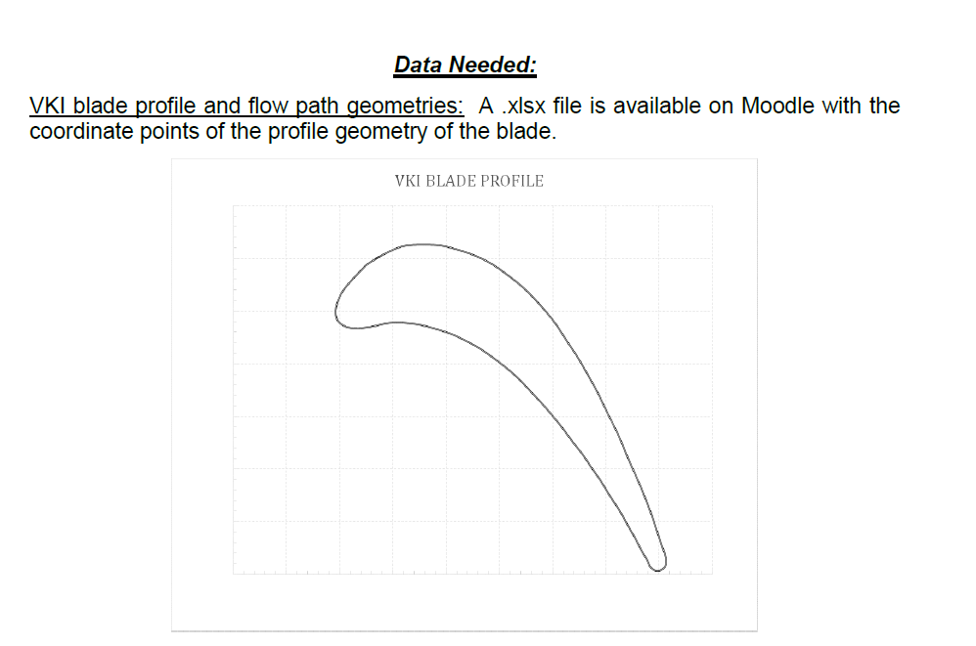

* Objectives:

1. Generate the geometry of the VKI turbine blade. A .xlsx file is available on Moodle with coordinate points of the blade profile and flow path geometries. You can use the coordinate points to generate the 3D geometry using any CAD software of your choice.
2. 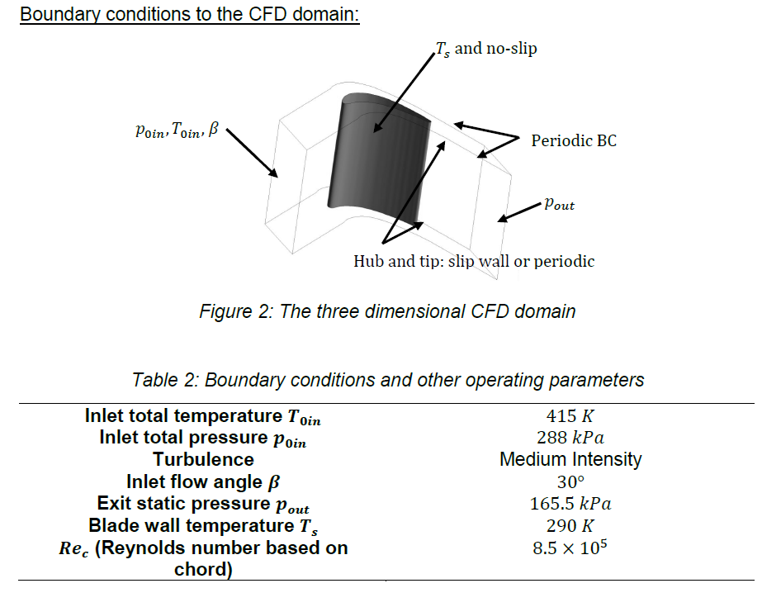Create a reasonably sized mesh (around 40,000 nodes) using ICEM CFD or ANSYS Workbench meshing applet. Discuss your mesh generation technique and your mesh size.

Figure 2-D Profile

1. Using ANSYS CFX, perform a CFD simulation of the meshed turbine cascade using the boundary conditions listed below and the 𝑘-𝜀 turbulence model.
2. Demonstrate graphically that your numerical simulation has converged by showing physical convergence of absolute values and numerical convergence. (Reference Proper Literature review)

Figure Boundary Conditions

1. Post process your numerical solution, and calculate turbine performance parameters:

a) Calculate the isentropic Mach number at the inlet and exit of the cascade.

b) Plot the isentropic Mach number distribution over the suction and pressure surfaces of the blade.

c) Calculate the total pressure loss across the blade.

d) Provide colored contours of the velocity, pressure, and temperature across the cascade. Use a reasonable scale and provide units in your legend.

1. Discuss your results.

# Methodology:

It encompasses the series of steps and decisions made throughout the simulation process to achieve accurate and meaningful results. Here's a general outline of the methodology involved in the operation of ANSYS CFX.

|  |
| --- |
| Figure 4 CFX Methodology |

## Geometry:

Geometry has been created using Modeling software SolidWorks with the help of given Co-Ordinates file. Once the geometry is modeled, arbitrary thickness is given to geometry to make a 3D profile. Our fluid domain is integrated with the blade profile thickness. After all the modifications, STEP or IGS file has been created to integrate geometry file with Ansys.

|  |
| --- |
| Figure 5 3-D Profile from SolidWorks |
|  |

## Meshing:

* Meshing is the most important parameter in CFD simulation. Mesh is discretization of space that allows the fluid to flow withing your control volume.
* The grid generation involves defining the structure and topology and then generating a grid on that topology.
* Currently all cases involve multi-block, structured grids; however, the grid blocks may be abutting, contiguous, non-contiguous, and overlapping.
* The resolution of boundary layers requires the grid to be clustered in the direction normal to the surface with the spacing of the first grid point off the wall to be well within the laminar sublayer of the boundary layer.
* 3-D model generated from SolidWorks is imported in Ansys CFX as STEP file. After that Quadratic Mesh has been generated in section 3 of the fluent tree. As mentioned in (Siddharth Suhas Kulkarni*, 2016) Size of mesh can be controlled by smallest element size, face meshing, Inflation factor etc.
* Here the results are obtained just by controlling size of the elements and face meshing in case of fine mesh.
* Face meshing is applied when your elements size is below 4 mm or No. of nodes exceeds 40000. In those cases, it is necessary to have fine mesh layer near blade profile as it captures boundary layer phenomenon near blades.
* Inflation factor can also be applied on this problem as a concept of Y+ factor ( (NUNO M. C. MARTINS, 2014)).
* Y+ factor is the Y+ is a dimensionless parameter that is a measure of distance from the first grid cell to the surface.
* The Y+ value determines the accuracy of the boundary layer thickness prediction. Incorporation of Y+ factor drastically increases the computational time of the solver Although it gives as accurate results as possible and as mentioned in (NUNO M. C. MARTINS, 2014) optimal design is always trade off between mesh quality and computation time due to limited resources available.
* Hence, we have varied our mesh quality just by changing element size and face mashing.

Following steps for mesh generation:

1. Open 3rd Section of solution tree
2. Create Name Selection
3. Apply element size of overall mesh.
4. Apply face sizing on blade when needed.

|  |
| --- |
| Figure 6 Mesh |
| |  | | --- | | Figure Mesh Quality near blade surface | |

## Simulation setup

* Mesh model is then transfer to setup section 4 as shown in fig (7).
* k-ε Turbulence model is applied and Air at ideal gas is selected as working fluid.
* Reference pressure is taken at 0 atm.
* It is implied that finite boundary conditions in terms for Total Pressure and Static Pressure has been given at Inlet, Outlet respectively.
* Blade profile is treated as wall with No-Slip condition and at constant temperature of 290K. Side Interface and Top-Bottom Interface is treated as periodic interface as we want linear cascade solution.
* We have also added an expression for mass flow rate that passes through the test section and monitor the same along the iteration.

|  |
| --- |
| Figure 8 Applied Boundary Conditions in setup |

* Solver control:
* Residuals can be controlled at solver phase. The residuals (for example for the RANS equations) are usually the difference between the left and the right side of the equations (convection-(source+diffusion+sinks)) summed over all the cells of the domain (and sometimes scaled with some factor). This is called the imbalance in the equations.
* In theory residuals should equate to the same but due to numerical errors they aren’t.
* When residuals decrease it means that the solved equation gets closer to being fulfilled.
* RMS value is started from 1e-15 to all the way 1e-20 as we decrease element size and No of Iteration kept at 2000.

## Results:

* After solution phase, converged solution is transferred to post-processor step where contours and graphs of all the physical properties can be seen.
* To generate contour plane has been created at mid thickness level which forms colored contour of different properties i.e., Total Pressure, Temperature, Mach number etc.

# Results and Discussion:

* Fluid flow problems posed by common products are highly nonlinear in nature. Only through imposing restrictive conditions can the governing Navier-Stokes equations be solved analytically. As a result, computational fluid dynamics (CFD) solutions must be calculated iteratively. This raises a question that how I trust CFD solutions.

There are three ways on how you can trust your results or three ways of convergence.

1. Numerical Convergence:
   * Error functions observed in solution of RANS equations can be used to monitor Numerical Convergence.
   * Your RMS value of U, V and W momentum with Mass value must go to certain constant value at the end of your solution.
   * In our case value of all the variable reached at certain value 1e-8 and 1e-15 in case of double precision and hence we can say that our solution at that setup and mesh parameter is Numerically converged solution.
   * Considering literature review of citation (Number), Solution is said to be numerically converged if residuals of all the variables reaches to certain desired value and remain constant.
   * In our case Solution As seen in fig () for give boundary condition and solution setup is numerically converged as residuals for U,V and W Momentum reaches to certain desired value of 1e-8 and 1e-15 in case of double precision.

|  |
| --- |
| Figure 9 Numerical Convergence of U,V,W Momentum |

1. Physical Convergence:
   * Physical convergence can be achieved through iterating same setup and mesh over different no of Iteration and over those iterations one physical property is monitored at plane.
   * If an error between last and first solution is minimum, then your solution is said to be a Physically converged solution.

|  |
| --- |
| Figure 10 Physical convergence in terms of Total pressure vs no of iterations |

1. Mesh Independence:
   * As cited in literature review 4(reference), Mesh size plays an important role in convergence of the system.
   * It is difficult to achieve perfectly mesh independence results with limited computing resources though it can be achieved with minimum error of properties that has been monitored over the blade profile.
   * Perfectly mesh independence result is the one in which reduction in mesh size does not affect the convergence of the problem.
   * As shown in fig (9), with the refinement in mesh size total pressure changes at exit plane and it become consistent after 80000 nodes which corresponds to mesh size of 3 mm. Although the values are not same there is some error can be found with further reduction in mesh size, but that error is consistent and is about 0.10%.
   * That leads to discussion on the mesh independent result at 3 mm and further reduction in mesh size doesn’t affect convergence in greater extent.
   * Also, from literature review (NUNO M. C. MARTINS, 2014), it can be said that an efficient mesh is one the allows balance between maximum accuracy and minimum computational effort. It is inevitable that increase in refinement leads to increase in computational error as it incorporates inflation in mesh near the boundary layer.
   * Hence, with the available resources the solution found with maximum accuracy can be stated as mesh independence solution which is at 3mm in our case.
   * All the contours displayed further is at mesh independent result at 3mm.

|  |
| --- |
| Figure 11 Mesh independence (No of Elements vs Total pressure) |

## 5.1 Isentropic Mach Number:

Isentropic Mach number is the Mach number that has been calculated without considering pressure flow loss. his property is often used to investigate the ideal surface Mach number you would have without losses and walls without any friction (slip conditions). Isentropic Mach number can be calculated using following formula.

## 

1. Isentropic Mach at Inlet:

P01 =

P1 =

γ = 1.4

Misent = 0.38286

1. Isentropic Mach at Exit :

P02 =

P2 =

γ = 1.4

Misent = 0.836619

## 5.2 Isentropic Mach distribution over the blade

* Mach number distribution can over the blade can be found by creating equally spaced planes over the suction and pressure surface as shown in fig. Also planes at leading and trailing edge must be created to get a value of pressure at those planes.
* With the help of function calculator static and total pressure can be found at those planes and after that Mach number at those points can be calculated using formula mentioned above.
* With the help of excel or MATLAB plotter we can get a graph of Isentropic Mach Number over the blade for suction and pressure surface.
* Calculated Mach number for all the locations over the blade is added in Appendix.

|  |
| --- |
| Figure 12 Isentropic Mach no distribution over blade profile |

* From fig (10), it is evident that maximum Mach number reaches at 70-80 percent of the blade profile. Although it is also noticeable that maximum isentropic Mach number goes above 1 which indicates flow separation and significant pressure loss at the pressure surface.
* When flow turning angle across the blade more than 90 degrees then wake regions and pressure loss regions are formed at suction surface of the blade. This type of losses are termed as aerodynamic losses.
* In our geometry flow turning angle is about 99.50 which creates zone of wake and flow separation.

|  |
| --- |
| Figure 13 Flow Turning angle across the blade |

## Total Pressure loss across the blade :

* As the working fluid moves through the blade passageways, several aerodynamic and thermodynamic processes contribute to the overall pressure loss across a turbine blade. When designing and analyzing turbines, this loss is a crucial factor.

P0 LE = 287570 Pa

P0 TE = 278283 Pa

Total Pressure loss = P0 LE - P0 TE

= 9.28 kPa

## Static Temperature Contours:

* Fig (11) shows temperature distribution over the blade profile. During the expansion process in turbine overall temperature decreases as hot fluid transfer energy at the blade which results in decrease in temperature of the fluid.
* As shown in fig temperature at pressure side is greater than temperature at suction side and low temperature region found at suction surface.

|  |
| --- |
| Figure 14 Temperature Contour |

## Static Pressure Contours:

* Fig (12) shows static pressure distribution over the blade profile.
* As shown in contour, Pressure across the suction surface is low compared to pressure surface. The pressure gradient from the pressure side to the suction side leads to the development of secondary flows.
* Due to the adverse pressure gradient on the suction surface downstream of the minimum Cp, there is the potential of boundary layer separation from the suction-side blade surface near the trailing edge and this represents a major source of profile losses in the blade passage.
* Boundary layer separation at the blade trailing edge can also occur due to a finite trailing-edge thickness and can lead to a distinct wake region.
* For blade profiles with higher camber angle can also occurs due to finite trailing- edge thickness and lead to a distinct wake region.
* With increased loading on the blade surface, suction surface pressures are reduced, and the velocity and Mach number over the suction surface increases with the local Mach number reaching supersonic values.
* At suction surface pressure rises in the adverse pressure gradient region and Fig. 1. boundary layer separation can occur earlier leading to increased profile losses for the highly loaded blade.

|  |
| --- |
| Figure 15 Pressure Contour |

## Velocity Distribution Contours:

* The velocity distribution on the blade surface near the end wall is also shown in figure (13).
* The suction surface velocity at blade profile is greater compared to pressure surface because of the strong secondary flow and higher-pressure gradient from pressure surface to suction surface.
* Similar trend follows in case of Mach Number, where sudden transition of Mach number leads to supersonic zone near to suction surface where flow acceleration takes place.
* In short camber angle defines velocity distribution over the blade surface higher camber angle leads to distinct wake region.

|  |
| --- |
| Figure 16 Velocity contour |

|  |
| --- |
| Figure 17 Mach Number Contour |

## Cascade View:

|  |
| --- |
| Figure 18 Cascade View |

# Conclusion:

* To conclude, Turbine design is an iterative process with the help of CFD tool with the selection of blade parameters such as Inlet and exit blade angles.
* During CFD analysis of Turbine blade mesh refinement is an important parameter that affects your results of convergence.
* As you move towards fine mesh region, you must introduce Y+ factor as cited in (Siddharth Suhas Kulkarni*, 2016) that can be applied near boundary layer domain as first layer height thickness. This factor refines mesh near the boundary layer.
* Since, highly loaded turbine, i.e., highly cambered blade is subjected to higher pressure gradient at suction side which creates aerodynamic loss in terms of flow separation at suction surface. (Dixon)
* Hence, reduced flow turning angle gives us better performance for the same geometry as it lowers the risk of flow separation.
* Detailed design procedure must be conducted while taking care of all three dimensionless parameters and must have to check whether given geometry parameters (β1 and β2) co-relate with empirical relationship from smith chart. That is also one way of validation to our results.
* As cited in (Joel Bjorkman, 2013), Our Inlet and exit boundary conditions affect our result as well.
* CFD Validation can be done using three types of convergence as mentioned above in which mesh independence is difficult to achieve with minimum resources available, which defines criteria of acceptance as a mesh independent result cited in (NUNO M. C. MARTINS, 2014), states that a result is said to be mesh independent if it gives maximum accuracy with minimum computational effort.

# Appendix:

* Tables of isentropic Mach number calculations

|  |  |  |  |
| --- | --- | --- | --- |
| Pressure surface | | | |
| Plane | Static Pressure | Total Pressure | Misen |
| LE | 242136 | 287590 | 0.501889959 |
| 28.026 | 273238 | 288016 | 0.275340031 |
| 38.028 | 272587 | 288003 | 0.281437371 |
| 48.02 | 265882 | 288062 | 0.340258673 |
| 58.02 | 246480 | 288058 | 0.477188533 |
| 68.02 | 201808 | 287959 | 0.731108024 |
| TE | 127709 | 276446 | 1.111009214 |

|  |  |  |  |
| --- | --- | --- | --- |
| Suction surface | | | |
|  | Static Pressure | Total Pressure | Misen |
| LE | 242136 | 287590 | 0.501889959 |
| 28.026 | 208613 | 287021 | 0.690810446 |
| 38.028 | 190154 | 286155 | 0.786942652 |
| 48.02 | 170644 | 285787 | 0.890875431 |
| 58.02 | 139071 | 285132 | 1.066950079 |
| 68.02 | 124127 | 276311 | 1.133288525 |
| TE | 127709 | 276446 | 1.111009214 |

* Tables for mesh independency:

|  |  |  |  |  |
| --- | --- | --- | --- | --- |
| Mesh Size | No of elements | Total Pressure at exit | Mach Number at exit | mass flow rate |
| 7 | 18526 | 256167 | 0.792128 | 0.40576 |
| 6.5 | 20875 | 257093 | 0.792861 | 0.40596 |
| 6 | 22403 | 260037 | 0.810757 | 0.40531 |
| 5.5 | 24857 | 261022 | 0.813697 | 0.40506 |
| 5 | 28426 | 262595 | 0.821396 | 0.40449 |
| 4.5 | 42261 | 260953 | 0.819616 | 0.40761 |
| 4 | 54216 | 262207 | 0.826576 | 0.4065 |
| 3.5 | 56826 | 261407 | 0.817468 | 0.40814 |
| 3 | 93357 | 261454 | 0.820795 | 0.40881 |
| 2.5 | 150521 | 261983 | 0.826255 | 0.40899 |

# References :

1. Dixon, S. (n.d.). Axial-flow Turbines: Two-dimensional Theory. In *Fluid Mechanics, thermodynamics of turbomachinery* (pp. 93-133).

2. Joel Bjorkman, J. M. (2013). *Design Pre-Study of a linear cascade test rig for Turbine Components.*

3. Mr. Monir Chandrala, P. A. (2012). CFD analysis of Horizontal Axis wind turbine blade. *International Journal of Engineering Research and Applications (IJERA) ISSN: 2248-9622*, 1,2,5.

4. NUNO M. C. MARTINS, N. J. (2014). Velocity-distribution in pressurized pipe flow using CFD: Accuracy. *ELSEVIER*, 9-12.

5.Siddharth Suhas Kulkarni*, C. C. (2016). Computational Fluid Dynamics (CFD) Mesh Independency Study of A Straight Blade Horizontal Axis Tidal Turbine. *Preprints*.

Staff. (2015, Jan 06).

*6.*Criteria for assessing CFD Convergence. Retrieved from engineering.com: https://www.engineering.com/story/3-criteria-for-assessing-cfd-convergence

7.Sumanta Acharya, G. M. (n.d.). *Turbine Blade*. Retrieved from https://netl.doe.gov/sites/default/files/gas-turbine-handbook/4-3.pdf: https://netl.doe.gov/sites/default/files/gas-turbine-handbook/4-3.pdf